|  |
| --- |
| AIS |
| Effort Estimate for Development of Integration components for XXXX Interface and XXXX Façade Gateway |
| Estimation Document |

|  |
| --- |
| Kumar Sinha, Ajoy  9/21/2016 |

* Documents for analysis
* XXXX Facade Gateway - Merchant Version.pdf
* XXXX - Interface Specification for Implementation by Parking Provider.pdf
* Q & A Document
* Scope

Development of Mobile application backend components to integrate with XXXX Interface and XXXX Façade gateway.

Any development / change / fix related with iOS and Android application UI related components are not in scope of this assessment

* Components will be Developed

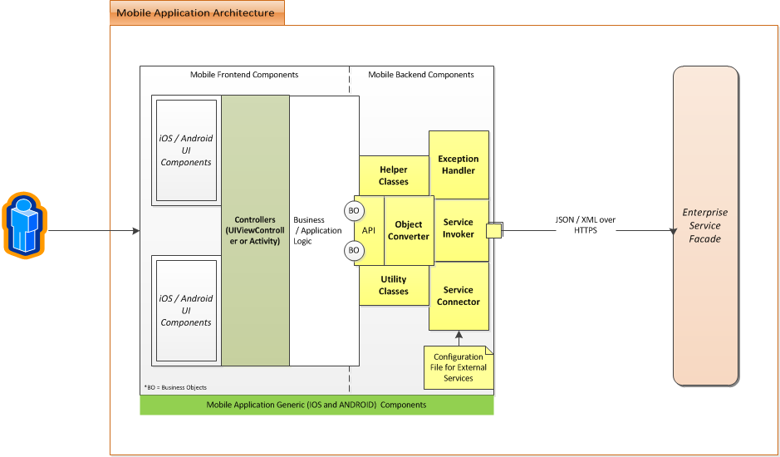

Yellow marked components will be developed

* Service Invoker : This will be used to invoke end points
* Service Connector : Configurable component ( with externalised configuration file ) to connect services
* Exception Handler : Will handle exception and wrap it in configurable format
* Utility Classes & Helper classes: This will be generic components for re use throughout the code.

All the above components will be developed for iOS and Android separately

* Assumption
* Existing Architecture, Design & Codebase will be shared to ensure compatibility during design phase
* Code will be developed using iOS and Android Best practices
* Security Best practices ( like using native SSL for communication ) will be used during development
* XXXX and XXXX services will be available and accessible throughout development / testing cycle
* Any support request from XXXX need to be resolved within SLA. This will ensure development completion in time.

* Effort

Total Required Effort is **54** PD [ Components for iOS and Android separately ]

2 Person will work for around 6 weeks. Both of the resources will work from India Offshore

Both the Resource will be of Level GCM **5**

**[One with iOS Development knowledge and one with Android development knowledge]**

* ROM (Rough Order of Magnitude)

**Min Value: 14000 USD**

**Max Value: 18000 USD**

* Plan

